Schools Social Media Post 1 – Registrations open
🎨 Feeling creative, <<School Name>> students?

We’re encouraging students to take part in the Queensland Parliament Education Cup, creating an artwork that shows what democracy means to you. 🏛️

Students in Years 4 to 12 can enter individually or collaborate as a team. This is your chance to get creative and showcase your ideas.

📢 Interested? Let your teacher know you’d like to be involved.

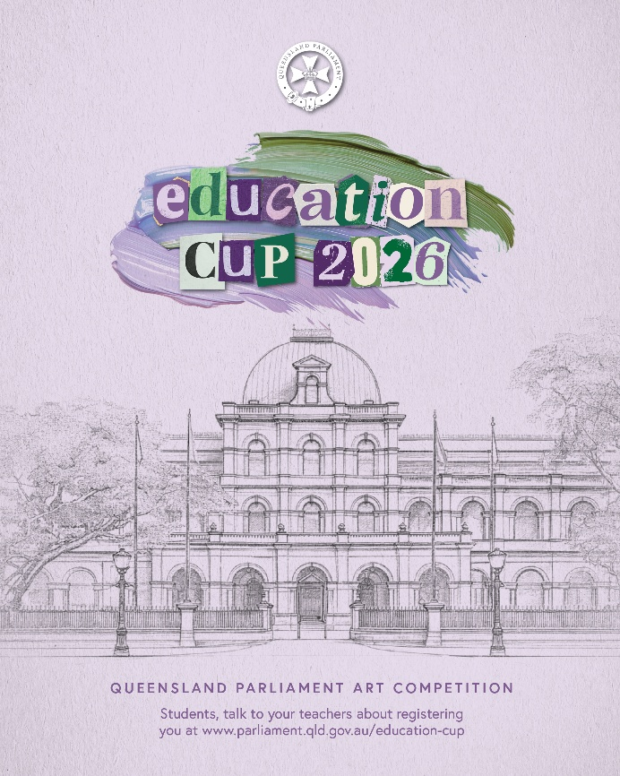

Schools Social Media Post 2 – General information

Your artwork could be displayed at Queensland Parliament.

We’re encouraging our students in Years 4 to 12 to enter the 2026 Queensland Parliament Education Cup, an art competition exploring:
“What does democracy mean to me?”

This is a great opportunity to get creative, build your confidence and share your ideas, while learning more about how our democracy works.

You can submit an individual artwork or collaborate as a team, using any materials on a flat surface.

Prizes include 🏆
• Artwork displayed at Queensland Parliament
• Recognition in Hansard, the official record of Parliament
• Gift vouchers from $100
• And the Education Cup with your name engraved on it.

📅 Entries close: Friday, 26 June 2026

📢 Interested? Speak to your teacher to get involved

Let’s see what our students can create!

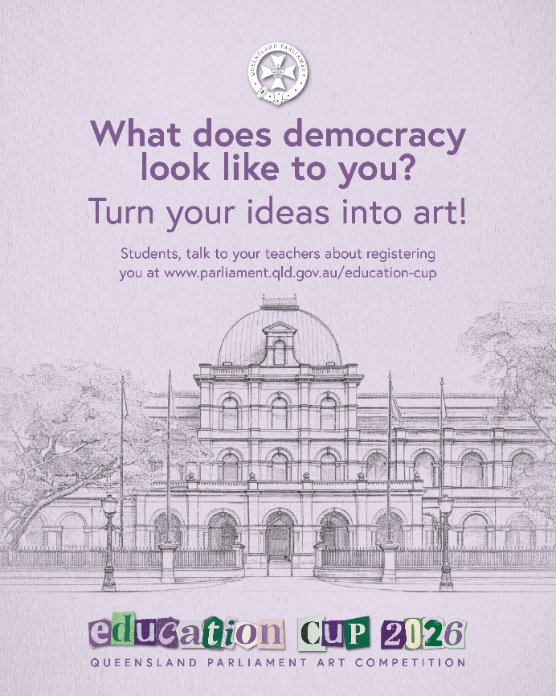

Schools Social Media Post 3 – Entries closing

🎨 Think your artwork has what it takes?

Let’s see <<School Name>> shine in the Queensland Parliament Education Cup! 🏆

Entries are closing soon, so now’s the time to get involved.

This is your chance to get creative, team up with friends and think big, using art to show what democracy means to you. 🏛️✨

📩 Register here: https://www.parliament.qld.gov.au/Education-Cup

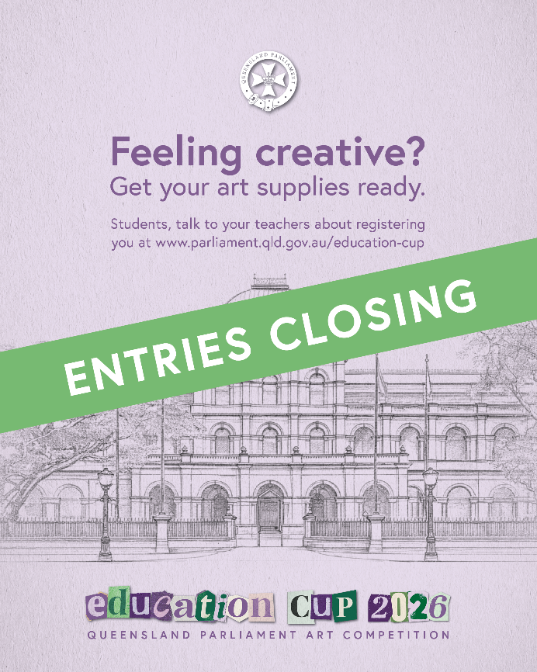

Schools Newsletter Insert

Got big ideas about democracy? Let’s see them!

Students in Years 4 to 12 are invited to take part in the 2026 Queensland Parliament Education Cup, using art to explore what democracy means to you.

Go solo or team up with friends to create an artwork responding to the theme: “What does democracy mean to me?”

Competition categories:
- Junior: Years 4–6
- Intermediate: Years 7–9
- Senior: Years 10–12.

Prizes include:
- Artwork displayed at Queensland Parliament
- Formal recognition in the Parliamentary Record of Proceedings (Hansard)
- Gift vouchers (Junior $100, Intermediate $200, Senior $300)
- Your name engraved on the Parliamentary Education Cup.

Entries close Friday, 26 June 2026.

Students interested in participating should speak with their teacher, who can register and submit entries on behalf of the school.

Learn more: https://www.parliament.qld.gov.au/Education-Cup

We encourage all students to take part in this exciting opportunity to showcase their ideas about democracy.

